**SOLAR FAULT BLOCK diagram**

POWER SUPPLY

SOLAR VOLTAGE SENSOR 1

ESP32

PROCESSOR

SOLAR VOLTAGE SENSOR 2

SOLAR VOLTAGE SENSOR (GND)

SOLAR CURRENT SENSOR

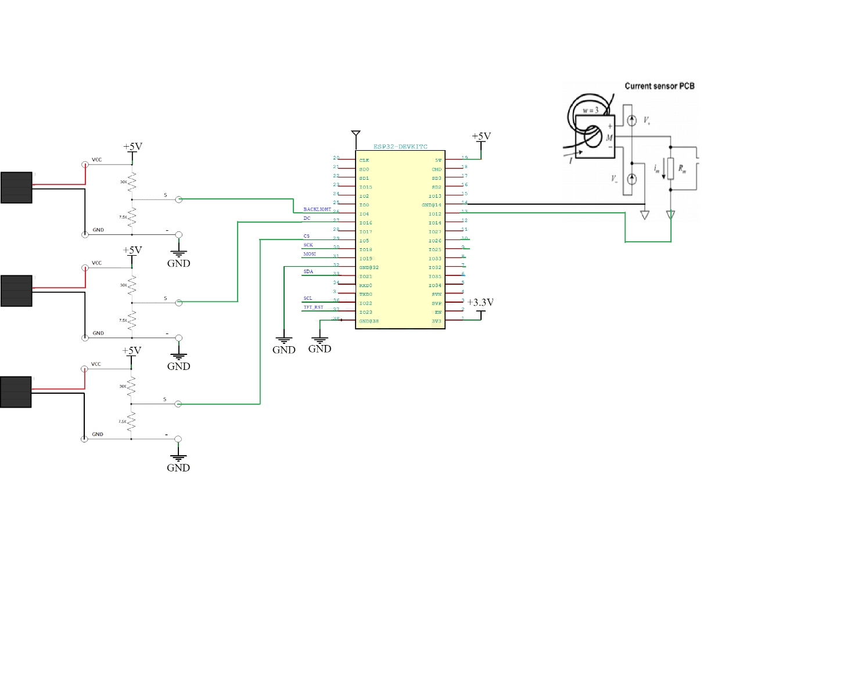 **SOLAR FAULT circuit diagram**